History of Computers

What’s a Computer?

Computer is a technology to proses instruction on data and cappable to store the instructions. Moore School of Engineering at the University of Pennsylvania in th 1930’s and ‘40s’ use a digital computer where created ENIAC. Meanwhile in the same period MIT use an analog computer. Data that is input and outpu within the digital computer is actually a voltage level that is 0 or 1. In analog computer, data representation is continuous and theres a limits of the power supplies.

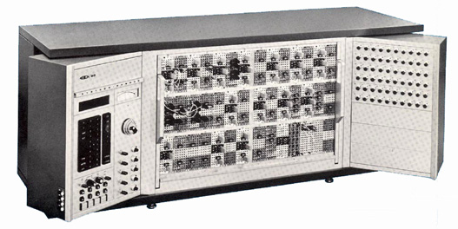

- Kelvin Feedback Technique
History of Computers
The first digital computer used by the Chinese people 3000-4000 years ago. Only for multiply and divide.
Pascal’s adding machine of 1642 inchance it but like abcus that’s still a calculator. Has the same purpose to store a program.

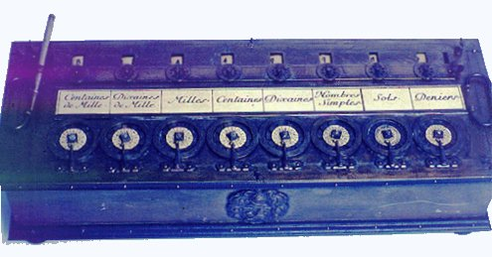

Program Storage

Jacquard used punch cards
Babbage used that in his difference engine and analytical engine
Ada Augusta and Babbage is considered the first programmer.
Hollerith used cards to tabulate the 1890.

An IBM Punch Card
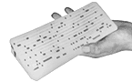

Babbage’s Difference Engine
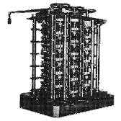
Early Computers
1942 - Atanasoff and Berry completed a prototype of the Atanasoff Berry Computer but not as perfect as the computer now.
1944 - IBM created the Mark I computer
1946 - Eckert & Mauchley’s ENIAC

Atanasoff-Berry Computer
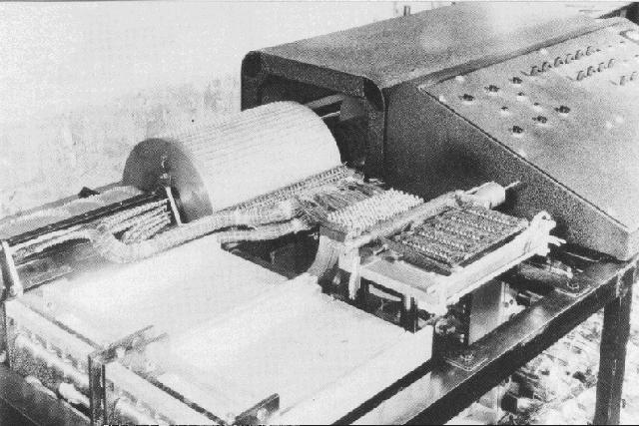

IBM Mark I
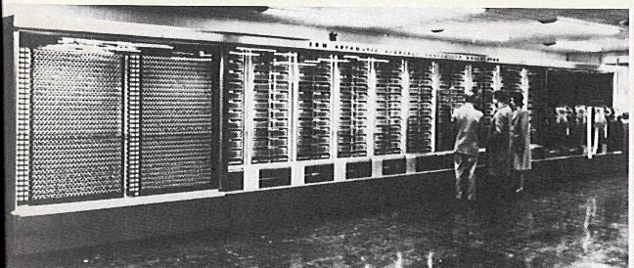

Relays
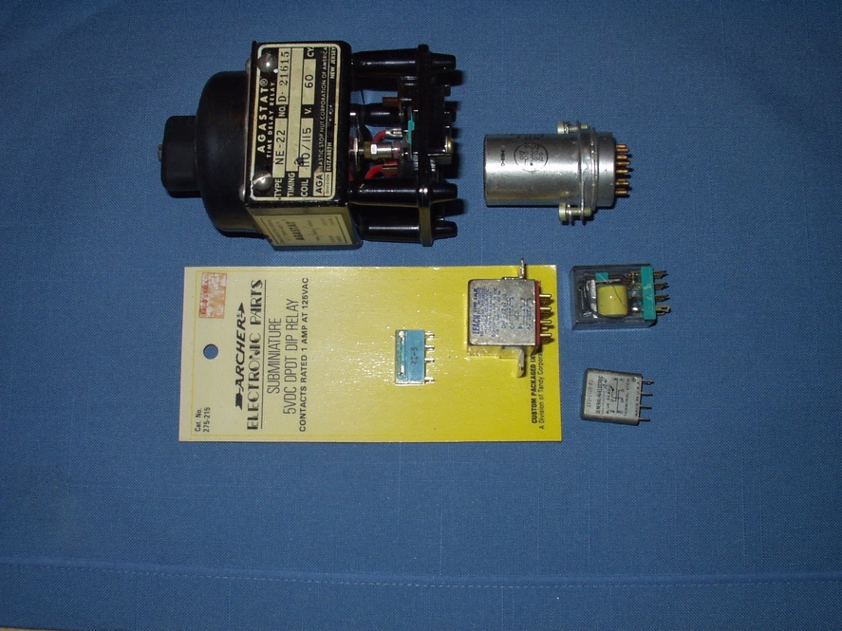

ENIAC
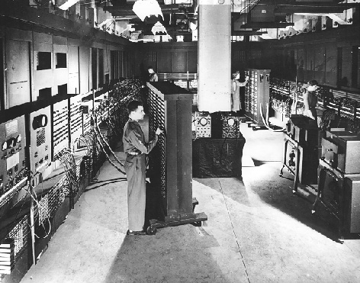

ENIAC On-A-Chip
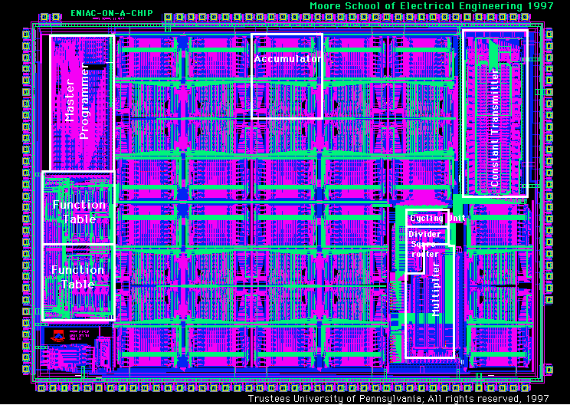

Early Antiaircraft Information
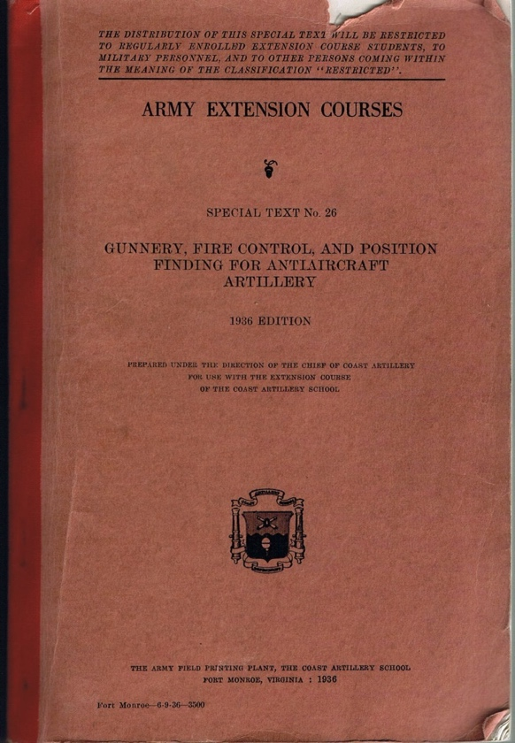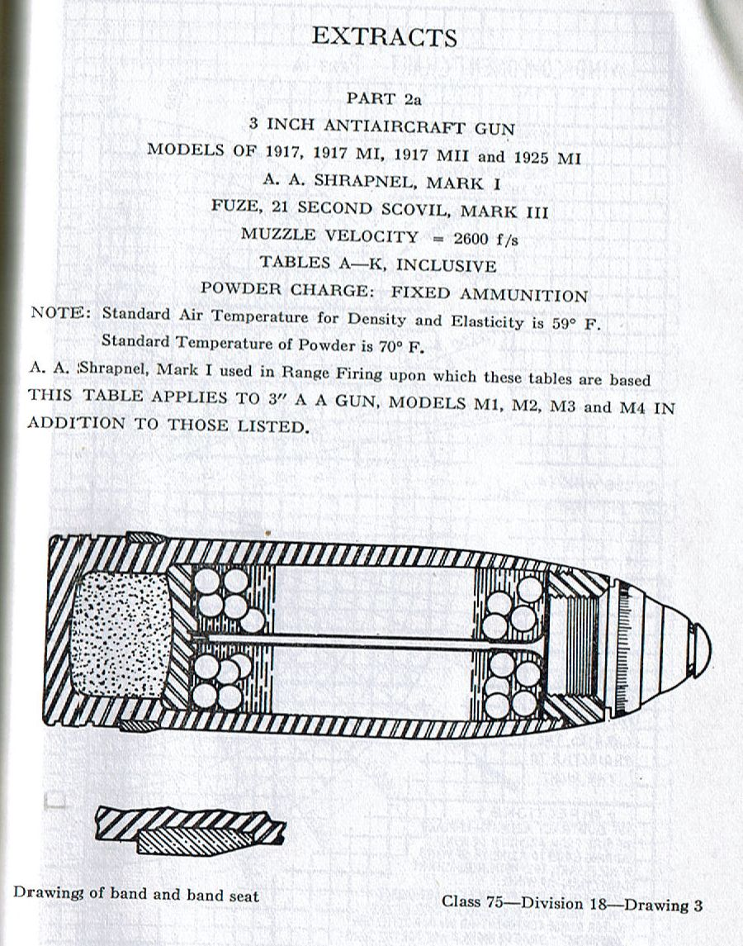

Finding Airplanes
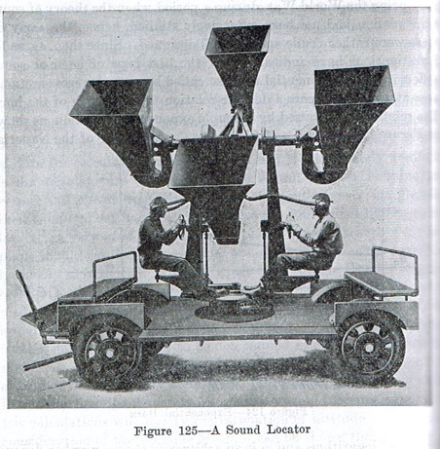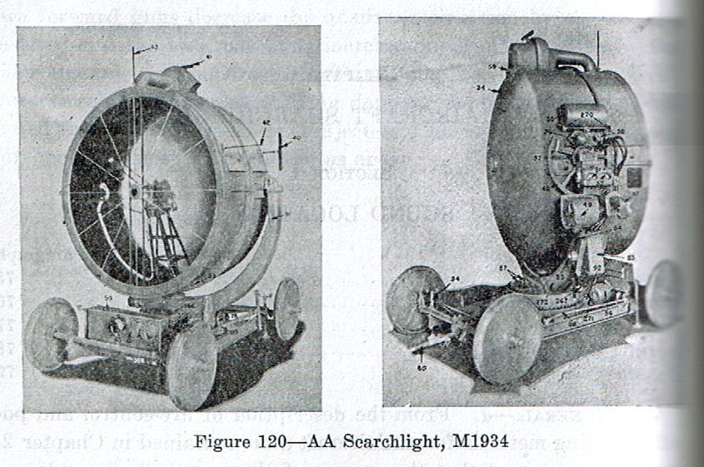
Aiming Corrections
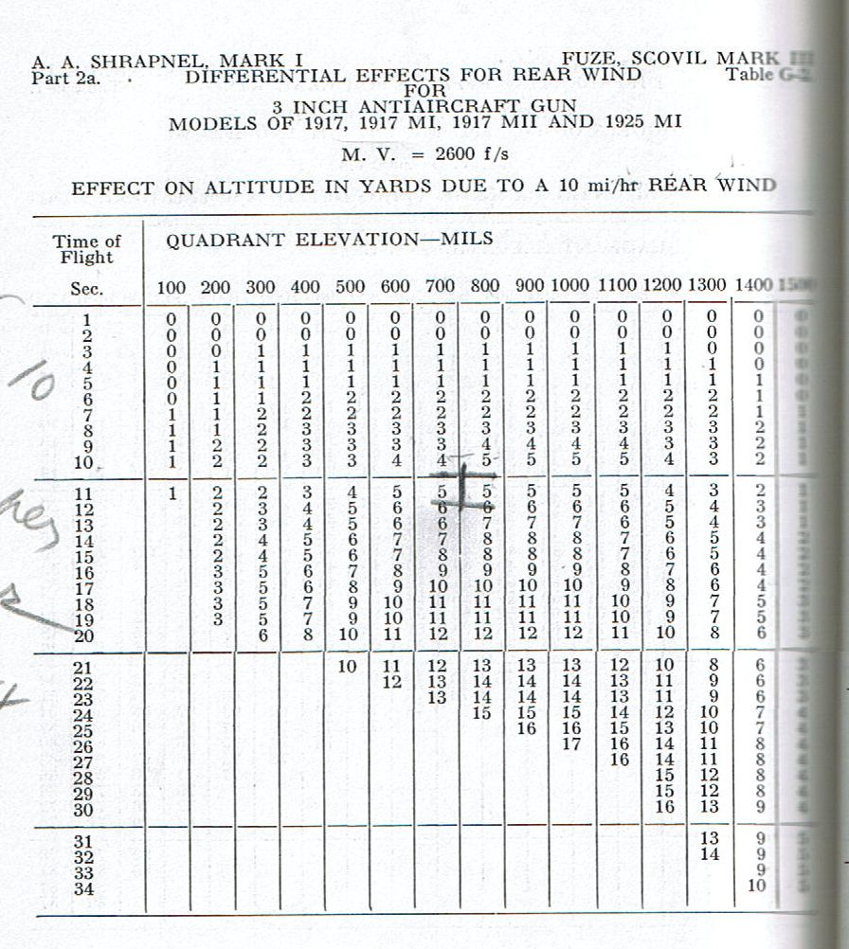

The “Real” Early Computers
ENIAC and ABC was first.
British COLLOSUS of 1943 was honored as the first.
German Zuse Z3 of 1941 wins but destroyed when theres a war.

Colossus (Reproduction)
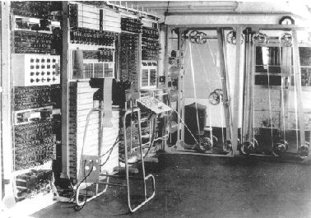

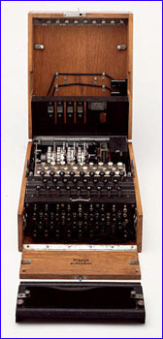
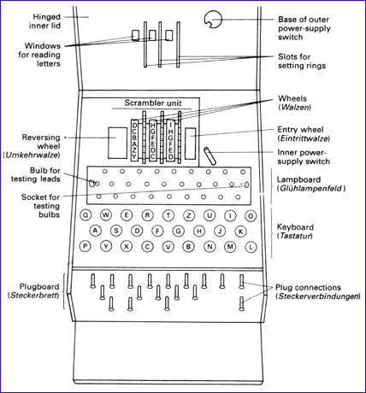
The Enigma Machine

Early US Computers pre-first generation
1946 - ENIAC - Electronic Numerical Integrator and Computer.
1949 - EDSAC - Electronic Delay Storage Automatic Calculator.
1951 - EDVAC - Electronic Discrete Variable Automatic Computer.

EDSAC
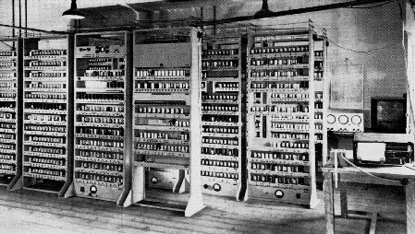

EDVAC Design
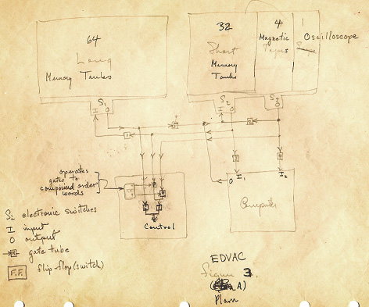

EDVAC
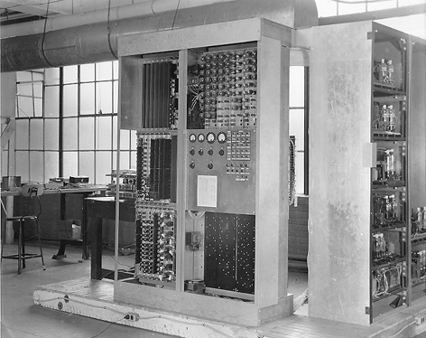

First Generation Computers
1951 - UNIVAC - UNIVersal Automatic Computer (performs add in 282 microsec).
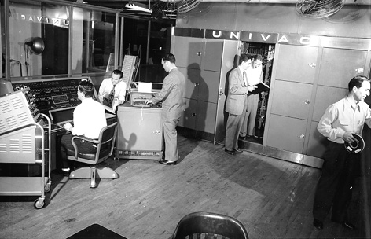
1952 - IBM 701 Data Processing System.
1953 - IBM 650.
UNIVAC, IBM 701, IBM 650 used vacuum tubes.
1955 - UNIVAC II was partially transistorized and considered generation one and a half.

Vacuum Tubes
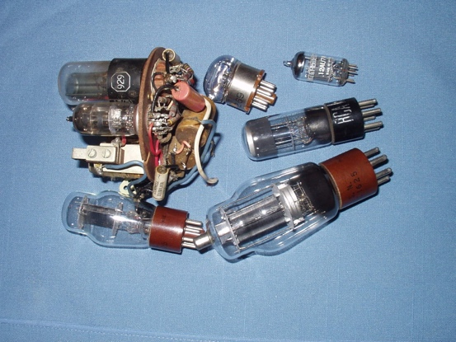

Second Generation Computers used transistors
1954 - TRADIC - Bell Labs first all-transistor computer.
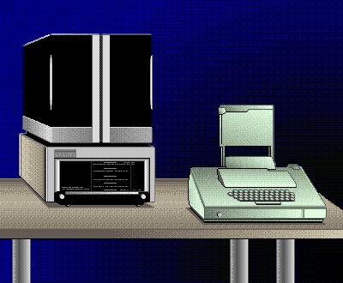
1958 - IBM 7070 & 7090.
1959 - IBM 1401.
1964 - CDC 6600.
300 nanosecond add (three orders of magnitude faster than first generation.
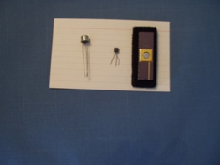
Transistors
Third Generation
Faster than second generation
1964 - IBM 360.
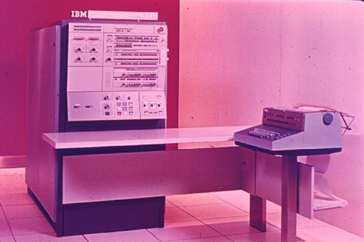
Not really any smaller than first generation.
Used integrated circuits rather than discrete transistors

Fourth Generation
Personal computers, using microprocessors and other integrated circuits.
Faster than third generation but cheaper

The Intel 8088
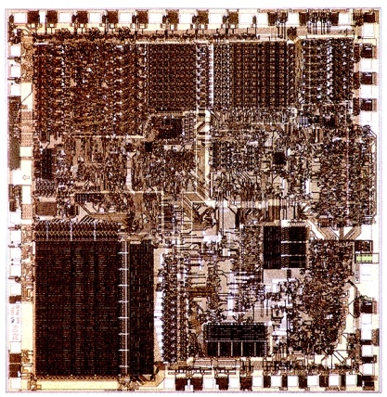

The Central Processing Unit

Construct by arithmetic logic unit.
Construct by several special and general purpose registers or accumulators.
Construct by bus interfaces for input and output

Language Hierarchy
High-level language (Ada, C, C++, Java, FORTRAN, Pascal, BASIC, COBOL, etc.)
Assembly language (symbolic, dependent on target processor/computer), mnemonics.
Machine language, understood by the actual processor/computer, opcodes and operands.

Some examples
add bal,eax ; 05 bal
jns elseIf ; 0F 89
Code
jmp endIf ; FF
elseIf: jnz elsePos ; 0F 85
Code
jmp endIf ; FF
elsePos: code
endIf:
if (iBal < 0)
{Statements
}
else if (iBal == 0)
{Statements
}
else
{Statements
}
/* end if */

So What is C?
C is a high-level compiled standardized language
Creating programs in the C leanguage
Run source files to proses that can be run on a spesific computer
The host is the computer wheres the programming is done
The target is where the program runned
The same but diferrent run compiller.

